## Merchant Name *Dataplor* Implementation POC: Dani *(IM to fill)* CX POC: *[IMP to Add]*

### 

| Notes Sections   *(AE to fill if they have, Implementation to be completion DRI on handoff)*   * Info on how merchant bills   Mostly flat fees negotiated with large clients. Sometimes bill a bundled amount, sometimes bill by line items  Invoicing schedules and revenue schedules are sometimes divorced, ie billing for 24 months of service but providing 30 months of service, etc  1) What is the merchant temperament?  Very competent but somewhat exhausted with the task ahead (and a new baby on the way for Slater)  Straight shooters and a pleasure to work with so far  3) What are the Tabs features that the key POC cares about?  Contract processing for billing and rev rec. Want to ensure we are helping them fix up and do their rev rec and ARR reporting correctly moving forward |
| --- |

### Billing model *(Entire Section: Implementation to fill section)* Are there unique things about the customer creation process for this merchant?

* Information on how merchant bills
* How contract is broken up
* One off things to know about the merchant

### Contract Processing Steps *(Entire Section: Implementation/Success to fill Post-Go Live)*

### **If the contract looks like the screenshot below, follow the steps, use the red font as a guide to where to find information**

**Example of Order Template of Data Services and Fees (**[**Garage example**](https://garage.tabsplatform.com/prod/contracts/4361748e-203d-4431-aee6-7f06286054c4/terms/revenue)**)**

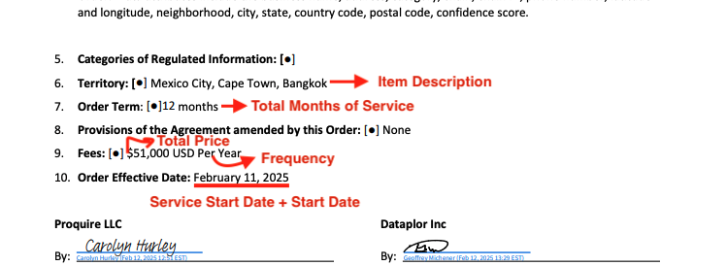

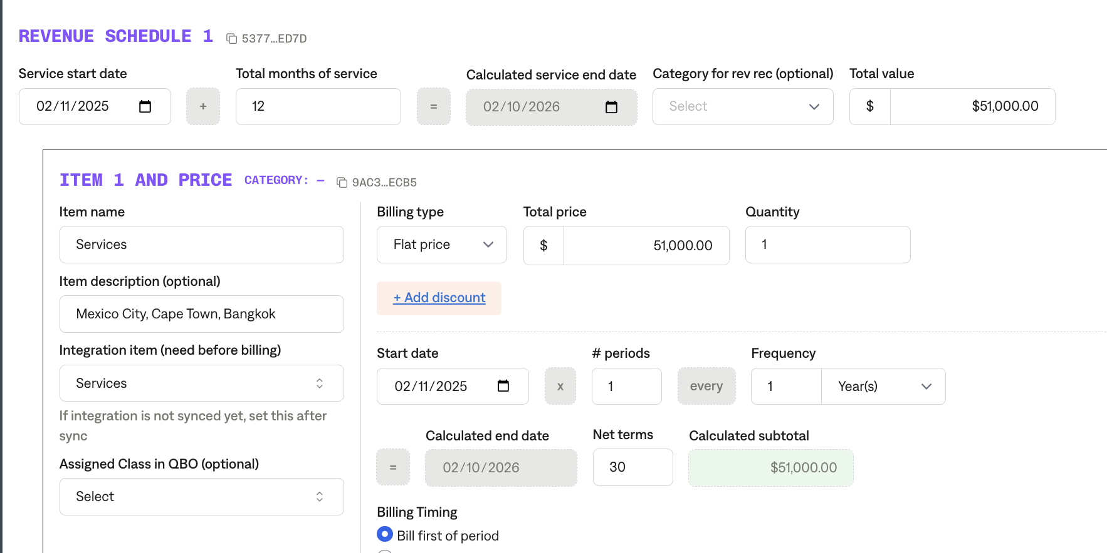

**Service Start Date:** Order effective date

**Months of Service:** Refer to the order term

**Item Name:** Fees

**Item Description:** Include the countries listed (or anywhere that lists the countries/territories that are included)

**Integration Item:**

**Billing Type:** Flat

**Total Price:** Listed in fees or search contract for where fees are listed

**Quantity :** Default 1  **Start Date:** Order effective date

**Periods:** a lot of these contracts are yearly but verify that the contracts states if it is just a one time charge

**Frequency:** a lot of these contracts are yearly but verify if the contract states yearly or monthly

**Example of REPRESENTATIONS contract (**[**Garage Example**](https://garage.tabsplatform.com/prod/contracts/2cf095cd-5d3e-480f-80d4-82c3bfad3a66/terms/revenue)**)**

**If the contract looks like the screenshot below, follow the steps, use the red font as a guide to where to find information**

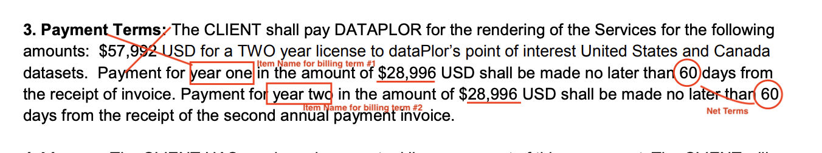

**Service Start Date:** Date listed in contract (will usually be in the first paragraph of the contract)

**Months of Service :** Recognize each billing term for the whole entire term of contract (example for this contract 24 months)

**Item Name:** Title it “year 1” or “year 2” if there are multiple payments

**Item Description**

**Integration Item**

**Billing Type:** Flat

**Total Price:** See the individual price for each year, not the total price

**Quantity :** default 1 **Start Date :** Start date for first year will be based on the service start date

For year 2, do 1 year after the start date or read the wording in the contract to figure out when the second payment is due

**Periods:** default 1

**Frequency:** See PAYMENT TERMS section and see how long the contract is, for this example

they are dividing it into two payments each year

**Customer Name**: Different locations of the same customer are treated as separate sub customers. Make sure the customer mapping reflects the correct location by creating or assigning subcustomer.

**One off examples:**

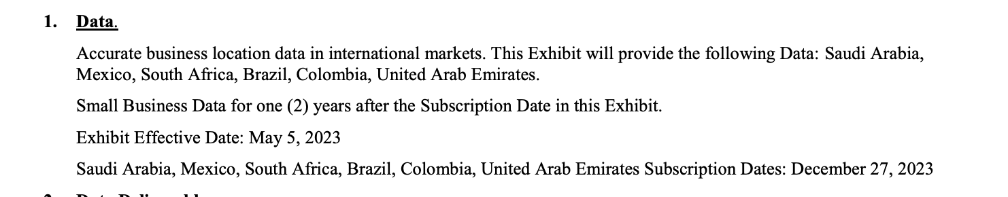

**If there is an EXHIBIT date, you will use that date as the Service Start Date and have the term end based on the subscription date.** Example: May 5th, 2023- December 27th, 2025

1. Anything to ignore in contracts?
2. Specifics processing things the merchant has requested that may differ by contract (e.g. always back-date invoice date to final day of the month)
3. Default Service Term
   1. If None Listed, Ops Default is 1 Year
4. Default Net Payment Terms
   1. If None, Ops Default is 0
5. Default Billing Frequency
   1. If None Listed, Ops Default is Monthly
6. How do we handle taxes as a line item?
   1. If None Listed, Ops Default is every tax line item becomes a BT

### Events Processing (if necessary) *(Entire Section: Implementation/Success to fill Post-Go Live)*

* Any important information on events billing

Integration Items Processing (if necessary)  
*(Entire Section: Implementation/Success to fill Post-Go Live)*

* What are the instructions for assigning integration items?
* Example: All Statsig integrations items should be labeled as “Sales”
* Example: All “Pinata” integration items should be labeled as “Software Subscription Bundle” unless otherwise noted by Merchant

Post Processing Communications (if necessary)  
*(Entire Section: Implementation/Success to fill Post-Go Live)*

* Does the Ops Team need to notify anyone on the team re: completion of processing batches in Implementation or Active phase?
* Who needs to be notified and when?
  + Example:
    - Who: Customer Success [Azmat Aziz] needs to be notified
    - Where: Messari internal merchant channel
    - When: contracts are processed [Merchant Phase: Active]

### Customer Information *(Entire Section: Implementation/Success to fill Post-Go Live)*

* Any important information on specifics customers of this merchant
  + Special memo’s certain invoices require
  + Invoice changes due to merchant/customer relationship

### Feature Requests *(AE to fill for all requests prior to Imp handoff, Imp to fill prior to go-live/Success to fill to fill Post-Go Live)*

* FR 1
  + What is it
  + Why it's important
  + Urgency

### Merchant Calls *(AE to fill for all videos prior to Imp involvement, Imp to fill prior to go-live/Success to fill to fill Post-Go Live)*

* Intro call with Slater: <https://us-56595.app.gong.io/call?id=3900800531128878533>
* Custom Demo with Slater and Helen: <https://us-56595.app.gong.io/call?id=2958238626902269142>